Yemen Overview – Week 1

Click on this link to watch a video to help you move forward in prayer: Yemen, My Heart Breaks #1
As you read the article below, be in prayer as well.

Yemen’s Humanitarian Crisis by Amiira Ann

Shariifa sat motionless in her little hut. She felt numb. Her husband had been killed in the fighting between the Yemeni rebels and loyalists, leaving her a widow and their children as orphans. How would they survive? There was no social system in this country, and with the war raging, food and medical services were already hard to come by. Hopelessness for the future threatened to paralyze her. Would she receive any help?

A Complex Crisis
Yemen has only been recognized as a united and independent country since 1990. Currently, it is one of the poorest nations and the worst humanitarian crisis in the world.¹ However, it has not always been a scene of such poverty. In biblical times, Yemen was the land of the Queen of Sheba and was called “fortunate Arabia.” Located at the southern tip of the Arabian Peninsula, the country spots tall mountains, barren deserts, beaches bordering the Red Sea, and exceptional landscapes. It produces coffee, gold, frankincense, and myrrh, along with oil and other mineral resources.
However, a series of complex civil wars and political struggles have brought deep instability to the country. President Ali Abdallah Saleh resigned during the Arab Spring of 2011, and his successor, Abdrabbuh Mansour Hadi, was also forced to flee due to a rebel uprising in 2015. Since then, conflict between the loyalists and the rebels, both sides backed by outside nations, has plunged the country into war. The ongoing violence has led to a collapse of infrastructure and ensuing famine. Few humanitarian groups are permitted to enter the country, leading to further health and hunger crises. The destabilization has also created a fertile environment for Al Qaeda, the Islamic State, and other terrorist groups to flourish.

Suffering Children and Families
In the midst of raging war, civilians have suffered the most. About half of Yemen’s population lives in areas directly affected by the conflict. Over 10,000 civilians have been killed,² a third of whom were children. Those who survive the fighting often face other terrible struggles. By April 2017, more than 3.3 million Yemenis had been forced to flee their homes, becoming refugees or internally displaced persons as they try to escape the worst hotbeds of violence.³
Because of destroyed infrastructure and mass migration, over 80% of the population is in need of humanitarian aid, but much international aid has been interrupted by the violence. As a result, an estimated17 million people, about 60% of Yemen’s population, live without reliable access to sufficient food, and over
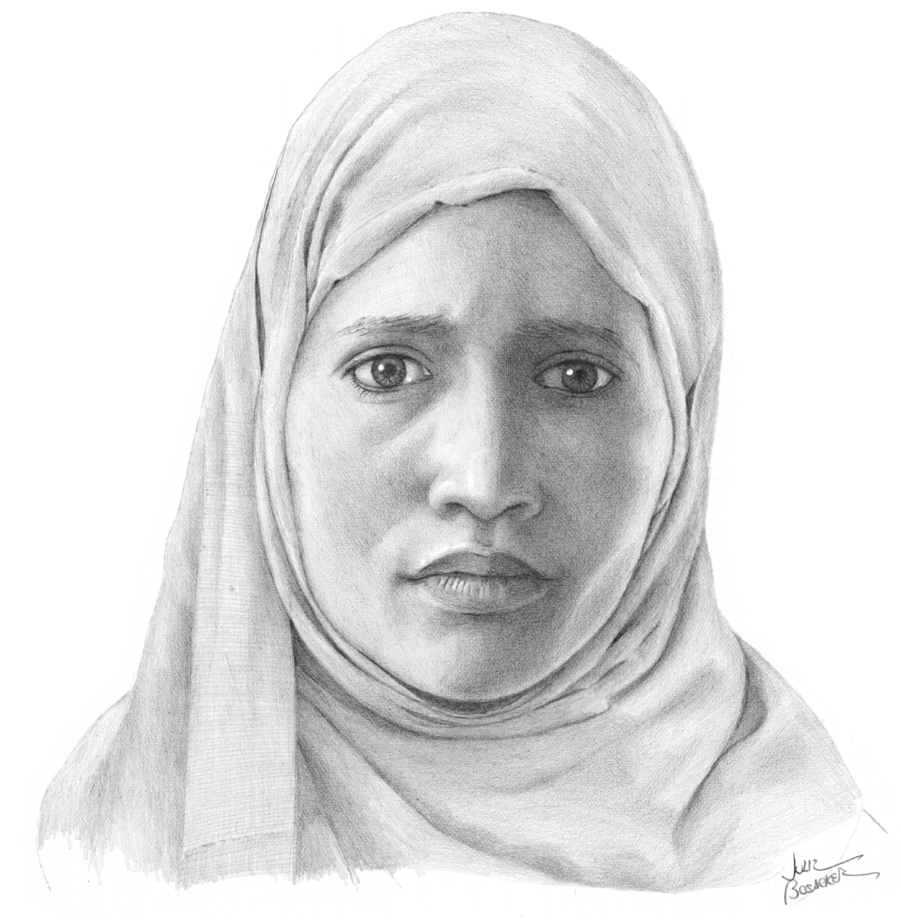half lack access to safe drinking water. 10.3 million require immediate assistance to save or sustain their lives. Malnutrition has increased by 57% since the beginning of the war, now affecting 3.3 million people. Children suffer disproportionately, especially those younger than five: the United Nations Children’s Fund estimates that a child dies every ten minutes from preventable causes. That means that nearly 150 children die in Yemen each day, or about 53,000 per year. Furthermore, many hospitals and schools have been destroyed or lack the supplies necessary to function. Over half of Yemen’s population lives without access to basic health services, and three million children are unable to attend school.⁴ In addition, many families have been torn apart. Women and children who lose their male head of household, in addition to mourning their losses, are singled out for oppression.

Persecution of Christians
Though life in a war-torn country is hard for all Yemenis, Christians face the added threat of religious persecution. Because of the ongoing war, non-Yemeni Christians have been expelled from the country, and the few Christian churches left in the country are targets of vandalism. Yemeni believers who remain in the country face persecution and even death. More than 99% of Yemeni citizens are Muslim, and those who convert to Christianity are threatened with the death penalty—not only by the government, but by members of their own communities.⁵ The risk is especially high for women. Family and community bonds are much stronger than those in the West, and Christian converts may be cut off from their social structure entirely. Worse still, a convert’s greatest suffering sometimes comes from within their own family. Not only must a new Christian face the choice between their faith and their most precious relationships, but they may even be killed by family members. Some view “apostates” who leave Islam as blemishes on the family’s honor and believe it is better to kill a Christian convert than allow them to leave Islam.

A Future and a Hope
Because of the risks associated with their faith, Yemeni Christians lived mainly as secret, isolated believers, afraid to meet with others who could betray them. However, in 2005 the Yemeni church suddenly rose up and the local secret believers and new converts organized an unofficial underground church, which has grown immensely despite suffering and persecution. Yemeni Christians started to meet together, even those who came from very different or even opposed backgrounds. Some are former Sunnis Muslims; others are former Shias. They are elderly people and teenagers, women and men, and people from different tribes and ethnic groups. They have a vision to grow spiritually and to help others, regardless of their religious or ethnic backgrounds. They set an example of unity, both for Yemen and for the world.
In the midst of dark times, Yemeni Christians are bold witnesses who testify that suffering for Christ is a part of being a Christian. Some have said, “We want to learn from our martyrs, both the expats and the locals who died for Christ, and grow in our faith!” They show their neighbors and relatives that there is a future and a hope, even in these difficult circumstances.

Pray…
• That the war in Yemen will stop, bringing an end to the terrorism and violence
• For widows and orphans
• For Yemeni Christians who are willing to stay and to be a light in the darkness
• For many Muslims to seek and accept Christ
• For effective help for millions of people who are threatened by famine
• For security for the Yemeni church and persecuted converts
• For boldness for the Yemeni church
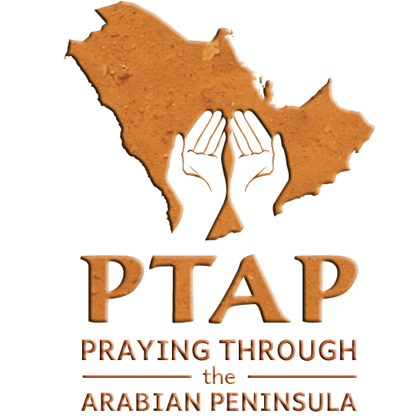
• For believers to help build a new future and not lose hope

Source: Taken from the 2018 Personal Prayer Diary and Daily Planner
(Seattle: YWAM Publishing)
Order at: YWAM Publishing

Yemen Tears – Week 2

Those who sow in tears shall reap in joy.
He who continually goes forth weeping,
bearing seed for sowing shall doubtless come again
with rejoicing bringing his sheaves with him.
Psalm 126:5,6

Tears in Scripture play a unique role in spiritual breakthrough. These verses in Psalm 126 reveal that the planting of seeds along with a spirit of brokenness will not only give a spiritual harvest, but will also impart the one sowing with a spirit of rejoicing in the process. Charles H. Spurgeon termed the “ministry of tears” as “liquid prayer.”

Click on this link to watch a video to help you move forward in prayer:
Yemen, My Heart Breaks #2

He will not shout or cry out,
or raise his voice in the streets.
A bruised reed he will not break,
and a smoldering wick he will not snuff out.
In faithfulness he will bring forth justice…
Isaiah 42:2-3

This week, we see the city of Sana’a, Yemen weeping for God to deliver them from oppression and injustice and for God to rescue those who have nowhere to turn.

“We feel our land is forgotten and that the world doesn’t know what is happening to us in Yemen. We cry night and day for things to change and for the great suffering of people here to end.”

We are turning to you God for the city of Sana’a Yemen. May the tears of travail that are falling from the prayers of Your people, water the ground of hardness that will open the soil for the seed of the Gospel. Make a way Lord, where there is no way. May a great witness come out of this city for your Name sake. Bring justice and restore what has been destroyed.
The LORD watches over the foreigner
and sustains the fatherless and the widow,
but he frustrates the ways of the wicked.
Psalm 146:9
Yemen End this War – Week 3

End this war

Click on these links to watch three videos to help you move forward in prayer
Five-year-old Buthaina A Prayer From Yemen Yemen, My Heart Breaks #3

The swollen face of Buthaina, swollen so bad from a Saudi air strike on the apartment where her family lived has been a rallying call to us all to open our eyes and look to see what is happening in Yemen. Her whole family perished from the attack. She was the sole survivor. Small children can spark anti-war reactions and bring change. May our prayers spark change in Yemen.

Pray…
- End this war in Yemen!
- That God would use the spotlight on Buthaina to help bring unity to different peoples, tribes, and religious forces in Yemen.
- For end of the bombing of Yemen. Pray for a peaceful conclusion to this violent war.
- For the Lord to send a spirit of forgiveness to Yemen among the warring tribes to bring about true and lasting peace.
- The war has caused widespread famine and the world’s worst cholera outbreak. Pray that those who are affected would receive treatment. Pray for the people to have a clean water supply.

Yemeni Believers – Week 4

Click on this link to watch a video to help you move forward in prayer: Yemen, My Heart Breaks #4
As you read the testimony below, be in prayer as well.
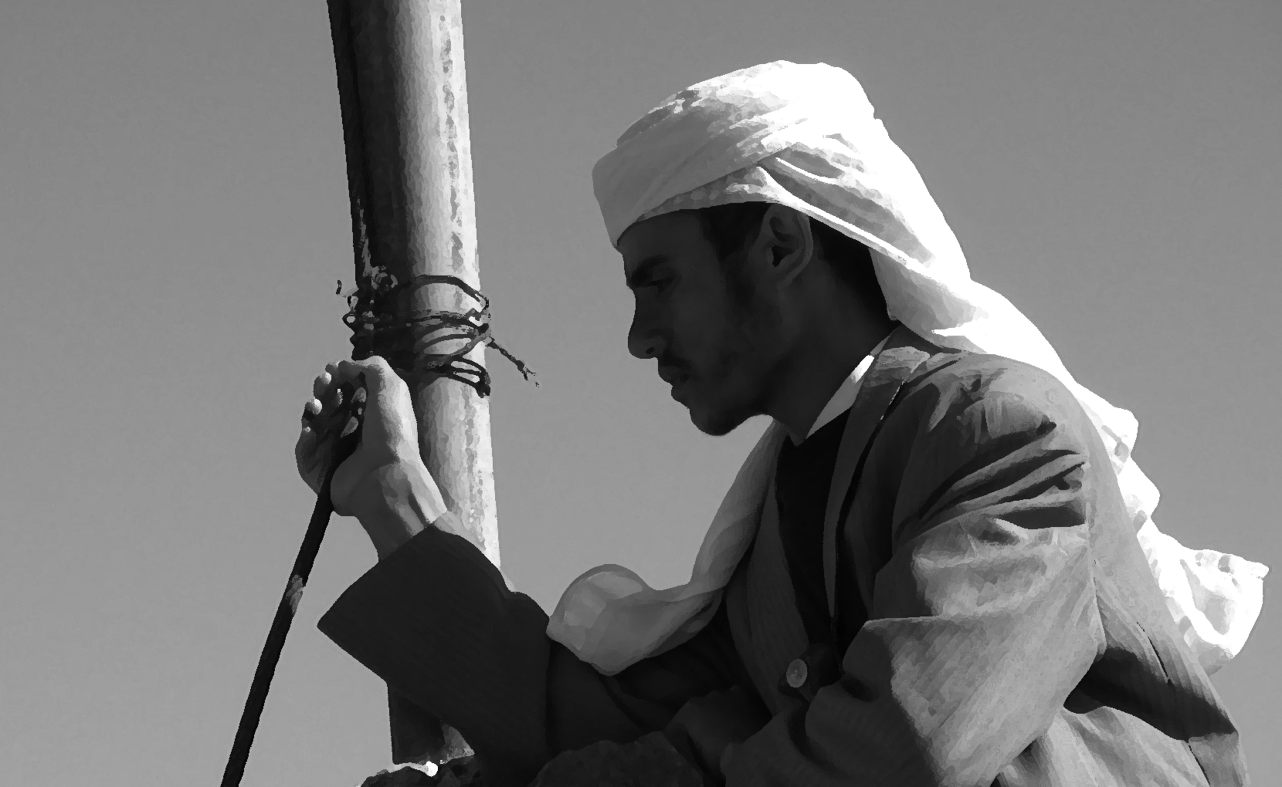

“Hasan*” was raised in a fundamentalist family in a small village in Yemen. He always went to the mosque with his father. When he was five years old, he was sent away to Quranic school. He was taught that Christians are to be hated. Even though he was a sensitive and friendly boy, he learned to hate. When he had the chance to move to Europe, he moved.
He tried to integrate and study. He knew how to hide his feelings of hate and had a European girlfriend. Soon she took him to church. He was touched by the friendliness of the people and by the things he had heard. He then started to have dreams about Jesus, but it took him a long time to get over his prejudices against Christians.
Hasan finally decided to follow Christ and decided to go back to his home country because he wanted his people to know the truth. He knew their culture and their language. He knew that he was called to his own people even though the circumstances were difficult. He wanted to obey God and serve him even though he knew it might cost him his life.
His family threatened him when they realized that Hasan was a “kaafir” (an infidel). They wanted him to become a Muslim again. His life became complicated because they treated him like an animal. However, he felt peace and he knew that Jesus was with him. God gave him courage and a supernatural joy. He didn’t want to go back to his old life.
Soon, one of his friends became a believer. Not long after that, his youngest brother and a sister followed his example. He rejoiced, but his father and his oldest brother put him into prison to get rid of him. Even in prison, he told others of Jesus and sang worship songs with them.

Thank God…
- for hundreds of believers in Yemen. Many of them are coming to faith as a result of the war. The church is growing despite the war!
- for leaders in the local Yemeni church who have a shepherd’s heart to take care of their flocks. Some of them have been killed for their faith. Others have been imprisoned for short or long periods of time. Hasan said: “After my first time in prison, I lost my fear. Jesus supported me and strengthened me. I started to minister to others who are living in fear.”
- that some of the believers are boldly sharing the gospel with their families, friends, and co-workers.
- for Christian media. It has been a good tool to broadcast the gospel to areas where no workers can go.
- for how he encourages the believers through corporate worship. They sing their own songs in Yemeni Arabic and read and study the Bible together as one body of Christ.

Pray…
- that the believers would continue to preach the gospel with boldness (Acts 4:29).
- that God would continue to build the Yemeni church in every region of the country (Matthew 16:18).
- for spiritual maturity and growth for the Yemeni believers. Pray that they would grow in the grace and knowledge of our Lord and Savior Jesus Christ (2 Peter 3:18).
- for the leaders of the Yemeni church. They need to grow in their qualifications as elders (1 Timothy 3).
- for love, even for their enemies, their persecutors (Matthew 5:42-48).
- that love would cast out all fear from their hearts (1 John 4:18).
- that God would physically provide for believers during this very difficult time of war. Pray that He would provide medical care, food, clean water, shelter, jobs with incomes, etc. according to his riches in glory in Christ Jesus (Philippians 4:19).
- that the local believers would be mobilized to help and serve their neighbors in their communities with humanitarian aid. Pray that the world would watch and see the love of Christ demonstrated in the lives of the believers.

* named changed, not his real name

